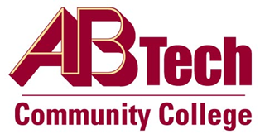

# Asheville-Buncombe Technical Community College

# (A-B Tech) Procedure

## Procedure 1003: Acceptable Use

In exchange for the right to use Information Technology College assets, employees will sign an annual attestation of the [North Carolina Acceptable Use Policy.](https://it.nc.gov/documents/statewide-acceptable-use-policy-aup) The Information Technology Services Division will be responsible for acquiring and maintaining these employee signatures annually.

Owner: Interim Vice President, President of Information Technology/Chief Information Officer, Ext. 7900

Updated: July 21, 2021